# Professor Dave Explains

## What is Professor Dave Explains?

**# Source**: **Chatgpt (GPT-5-Standard) at [8/27/2025]**

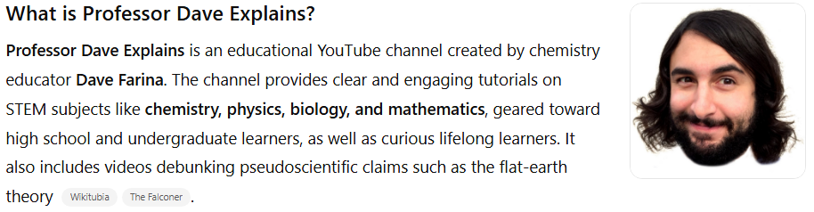

**Professor Dave Explains** is an educational YouTube channel created by chemistry educator **Dave Farina**. The channel provides clear and engaging tutorials on STEM subjects like **chemistry, physics, biology, and mathematics**, geared toward high school and undergraduate learners, as well as curious lifelong learners. It also includes videos debunking pseudoscientific claims such as the flat-earth theory ([Wikitubia](https://youtube.fandom.com/wiki/Professor_Dave_Explains?utm_source=chatgpt.com" \o "Professor Dave Explains | Wikitubia - Fandom), [The Falconer](https://torreypinesfalconer.com/3827/feature/qa-with-professor-dave-explains/?utm_source=chatgpt.com), [YouTube](https://www.youtube.com/professordaveexplains?utm_source=chatgpt.com)).

## Key Highlights

**# Source**: **Chatgpt (GPT-5-Standard) at [8/27/2025]**

* **Platform:** YouTube
* **Language:** English
* **Content Focus:** STEM education—chemistry, physics, biology, math, and scientific literacy
* **Subscribers:** ~3.91 million (as of August 2025) ([Social Blade](https://socialblade.com/youtube/handle/professordaveexplains?utm_source=chatgpt.com), [SPEAKRJ](https://www.speakrj.com/audit/report/UC0cd_-e49hZpWLH3UIwoWRA/youtube?utm_source=chatgpt.com), [vidIQ](https://vidiq.com/youtube-stats/channel/UC0cd_-e49hZpWLH3UIwoWRA/?utm_source=chatgpt.com))
* **Total Views:** ~429 million ([Social Blade](https://socialblade.com/youtube/handle/professordaveexplains?utm_source=chatgpt.com), [SPEAKRJ](https://www.speakrj.com/audit/report/UC0cd_-e49hZpWLH3UIwoWRA/youtube?utm_source=chatgpt.com), [vidIQ](https://vidiq.com/youtube-stats/channel/UC0cd_-e49hZpWLH3UIwoWRA/?utm_source=chatgpt.com))
* **Style & Aim:** To increase science literacy by offering tutorial-style educational videos that explain how things work in everyday life and academic contexts ([YouTube](https://www.youtube.com/c/ProfessorDaveExplains?app=desktop&utm_source=chatgpt.com), [The Falconer](https://torreypinesfalconer.com/3827/feature/qa-with-professor-dave-explains/?utm_source=chatgpt.com)).

## Summary Table

**# Source**: **Chatgpt (GPT-5-Standard) at [8/27/2025]**

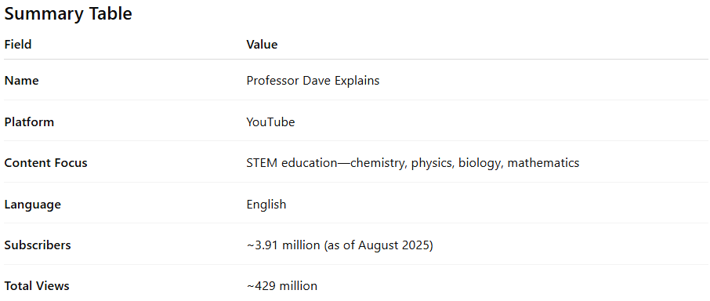

| **Field** | **Value** |
| --- | --- |
| **Name** | Professor Dave Explains |
| **Platform** | YouTube |
| **Content Focus** | STEM education—chemistry, physics, biology, mathematics |
| **Language** | English |
| **Subscribers** | ~3.91 million (as of August 2025) |
| **Total Views** | ~429 million |